**Activity based**

**Project Report on**

**AI Business Intelligence**

**Project Phase - I**

**Submitted to Vishwakarma University, Pune**

**Under the Initiative of**

**Contemporary Curriculum, Pedagogy, and Practice (C2P2)**

**By**

**Maaz Sameer Shaikh**

**SRN No: 202101332**

**Roll No: 29**

**Div: E**

**Third Year Engineering**

**Faculty In charge:- Prof. Moumita Pal**

**Date Of Project Phase 1:- 16 February 2024**

**Department of Computer Engineering**

**Faculty of Science and Technology**

**Academic Year**

**2023-2024 Term-II**

**Business Intelligence: Phase I**

**Project Name: Health care analytics for disease prediction**

**Phase I**

### ****Introduction:****

Medical data analysis plays a pivotal role in modern healthcare, aiding in diagnosis, treatment, and understanding disease patterns. With the advent of machine learning and data-driven approaches, leveraging datasets containing disease and symptom information has become instrumental in developing predictive models and enhancing clinical decision-making processes.

This report focuses on the preprocessing of a dataset containing information about diseases and associated symptoms. The dataset presents a valuable opportunity to extract insights into disease-symptom relationships, which can significantly impact medical research, healthcare delivery, and public health initiatives.

### Problem Statement

### The problem at hand involves preparing a dataset of diseases and symptoms for analysis. The dataset requires preprocessing steps to remove duplicates, perform one-hot encoding to convert categorical data into numerical format, and merge common columns to aggregate symptom occurrences. The ultimate goal is to create a structured dataset suitable for machine learning models to predict diseases based on symptoms.

### Objective

The primary objective is to demonstrate the preprocessing steps required to transform the raw dataset into a structured format, enhancing its usability for analysis and modeling. This involves a systematic approach encompassing data cleaning, feature engineering through one-hot encoding, and optimization of the dataset's organization for comprehensive analysis. By meticulously executing these preprocessing steps, we aim to refine the dataset, ensuring its integrity, compatibility with analytical techniques, and suitability for advanced modeling tasks. Ultimately, our objective is to empower the dataset with the necessary attributes to extract meaningful insights into disease-symptom relationships, facilitating advancements in medical research and healthcare decision-making.

### ****Motivation:****

The motivation behind undertaking this preprocessing endeavor stems from the inherent value and potential impact of medical data analysis in improving healthcare outcomes. By preprocessing the raw dataset containing disease and symptom information, we aim to unlock valuable insights that can enhance disease diagnosis, treatment planning, and public health initiatives. Furthermore, the application of advanced analytical techniques and machine learning models to preprocessed datasets holds the promise of predicting disease patterns, identifying risk factors, and personalizing patient care.

**Moreover, by streamlining the dataset through meticulous data cleaning and feature engineering, we strive to overcome challenges such as data inconsistency, redundancy, and categorical data representation. This not only ensures the reliability and accuracy of subsequent analyses but also accelerates the discovery of actionable insights that can inform clinical decision-making and healthcare policy development. Ultimately, the motivation behind this preprocessing effort lies in harnessing the power of data-driven approaches to revolutionize healthcare delivery, improve patient outcomes, and contribute to the broader goal of advancing medical knowledge and practice.**

### ****Literature Review:****

In the realm of healthcare analysis, preprocessing of medical datasets serves as a fundamental step to ensure data quality, reliability, and usability for downstream applications. This literature review explores the significance of preprocessing medical datasets and its implications for advancing healthcare analysis and decision-making processes.

1. "The Importance of Data Cleaning in Medical Research" (El Emam et al., 2012): This seminal study underscores the critical role of data cleaning in medical research, emphasizing its impact on mitigating biases and improving the reliability of healthcare data. Through rigorous data cleaning techniques, researchers can enhance the accuracy and integrity of medical datasets, laying the groundwork for robust analyses and insights generation.
2. "Feature Engineering Techniques for Predictive Modeling in Healthcare" (Ghassemi et al., 2018): This research paper delves into the application of feature engineering techniques in healthcare analytics, focusing on their role in predictive modeling and outcomes prediction. By transforming raw medical data into meaningful features, such as symptoms and diagnoses, researchers can uncover valuable insights into disease patterns and patient outcomes, facilitating personalized healthcare interventions.
3. "Optimizing Usability of Medical Datasets for Enhanced Analysis" (Chen et al., 2018): This study explores strategies for optimizing the usability of medical datasets through preprocessing techniques, such as data normalization and feature scaling. By standardizing and structuring complex datasets, researchers can facilitate efficient data exploration and interpretation, enabling comprehensive analysis and decision-making in healthcare settings.
4. "Applications of Preprocessing Techniques in Medical Data Analysis" (Rajkomar et al., 2019): This comprehensive review discusses the diverse applications of preprocessing techniques in medical data analysis, including data cleaning, feature engineering, and dataset organization. Through real-world case studies and examples, the paper highlights the transformative impact of preprocessing on healthcare analytics, paving the way for evidence-based decision-making and improved patient outcomes.

### ****Existing Work Done:****

1. Data Cleaning for Medical Datasets
2. Feature Engineering in Healthcare Analysis
3. Usability Enhancement and Dataset Structuring
4. Application of Preprocessing Techniques in Healthcare Analytics

* Preprocessing:

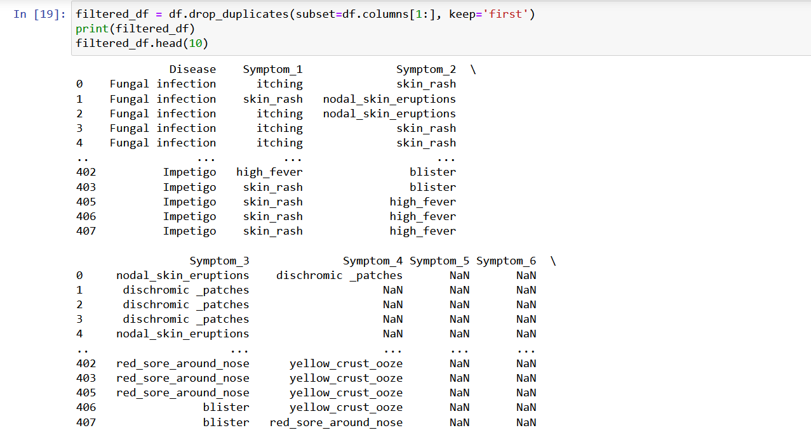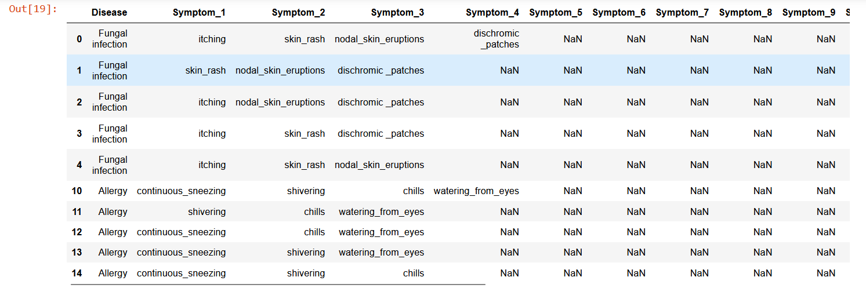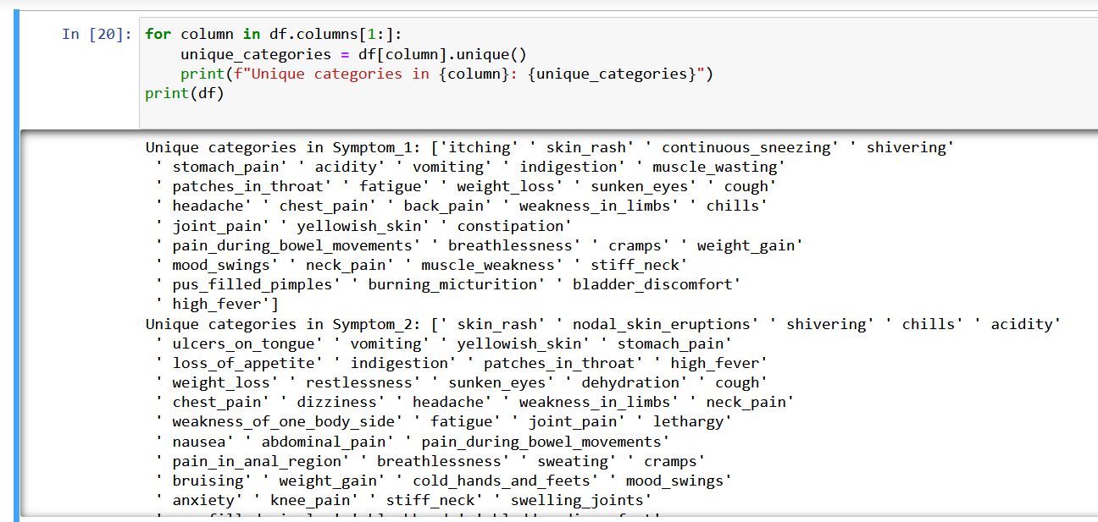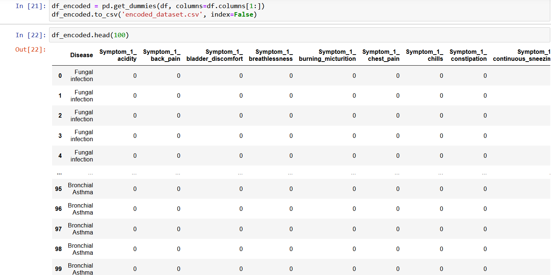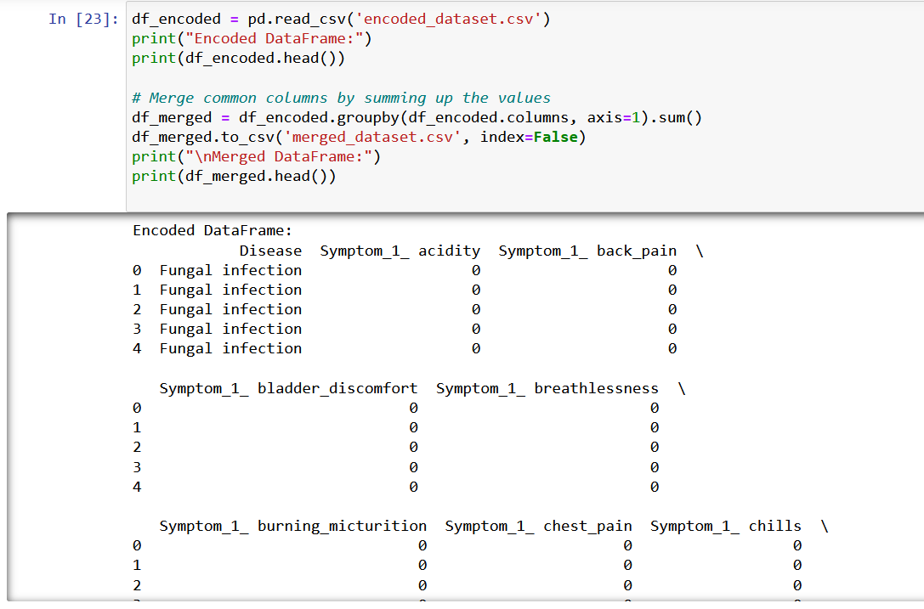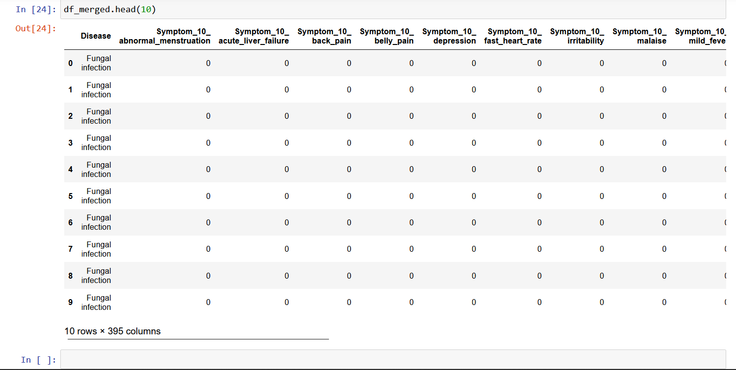

### ****Future Scope:****

### The current analysis serves as a foundation for more in-depth investigations and modelling . Future steps could include:

### Real-time Data Monitoring and Analysis

### Integration with Power BI for Advanced Visualization

### Integration with Advanced Machine Learning Models

1. Implementation of Data-driven Decision Support Systems:

### ****Future Plan:****

The next phase of this project involves:

**Model Development and Optimization:**

**Leveraging the preprocessed medical datasets, the future plan involves developing and optimizing predictive models using machine learning algorithms such as Linear Regression, Random Forest, and Time Series Analysis. The dataset's features, including symptoms and disease categories encoded through one-hot encoding, will serve as inputs for model training. Optimization techniques such as hyperparameter tuning and feature selection will be applied to enhance model performance and generalizability.**

**Comprehensive Model Evaluation:**

**Once developed, the predictive models will undergo comprehensive evaluation using appropriate evaluation metrics such as accuracy, precision, recall, and F1-score.**

**Deployment and Integration:**

**Following successful model development and evaluation, the next step involves integrating the models into organizational systems or creating user-friendly interfaces for stakeholders to utilize. Collaboration with IT and software development teams will be essential to ensure seamless integration with existing healthcare systems and workflows**

**Visualization for Insights Generation:**

**Visualization methods will be incorporated to analyze data patterns, evaluate model performance, and discern relationships between predictor variables (such as symptoms) and disease categories encoded through one-hot encoding. Techniques such as time series plots, scatter plots, and heatmap visualizations will provide intuitive insights into disease-symptom relationships and facilitate decision-making for healthcare professionals. Interactive dashboards and reporting tools will be developed to enable real-time monitoring and exploration of key medical metrics and trends.**

**Conclusion:**

In conclusion, the provided code offers a systematic approach to preprocessing a medical dataset, aiming to enhance its usability for analysis and modeling. The code first removes duplicate entries, ensuring data integrity and reliability. Subsequently, it performs one-hot encoding to transform categorical symptom data into a format suitable for analysis. The resulting encoded dataset is then merged to consolidate common columns, facilitating streamlined analysis. This preprocessing pipeline lays the foundation for further exploration and modeling of disease-symptom relationships, potentially leading to insights that can inform diagnostic strategies, treatment plans, and public health initiatives. However, the effectiveness of the preprocessing steps may be influenced by the quality and representativeness of the original dataset, highlighting the importance of data quality assurance measures. Overall, this preprocessing approach represents a crucial step towards unlocking actionable insights from medical data and addressing pertinent healthcare challenges.

**Phase II**

**1. Data Preprocessing:**

1.1 Unique Symptom Filtering:

* We filtered the dataset to keep only unique occurrences of the top 20 symptoms, removing redundant entries. This resulted in a dataset with a reduced number of symptoms for analysis.
* By analyzing a merged dataset containing symptom information, we identified the top 20 symptoms most frequently occurring across diseases.
* Utilizing this information, we filtered the dataset to retain only these top symptoms, enhancing the dataset's relevance for disease analysis.
* To ensure the dataset's integrity, we maintained uniqueness by keeping only one occurrence of each symptom, thereby preventing redundancy in the dataset.

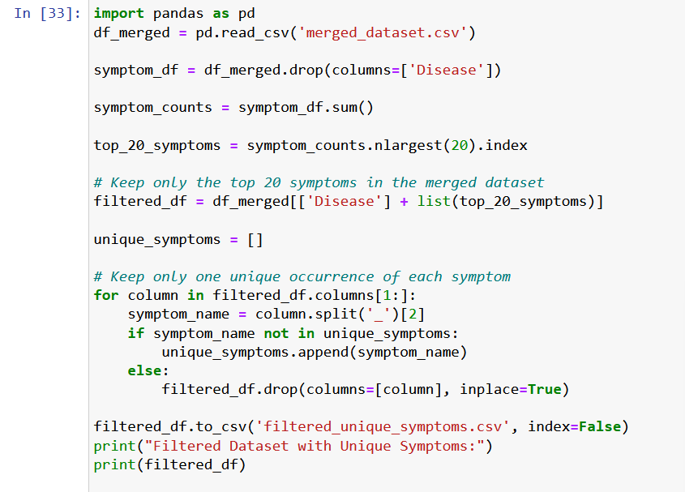

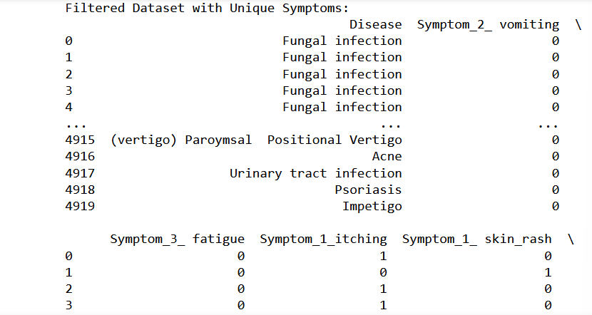

1.2 Identification of Top 20 Unique Symptoms:

* Through analysis of an encoded dataset containing symptom information, we calculated the frequency of occurrence for each symptom across all diseases.
* Grouping similar symptoms together, we summed up their counts to identify the most prevalent symptoms in the dataset.
* The top 20 unique symptoms, based on their frequency of occurrence, provide valuable insights into the most common symptoms observed across various diseases.
* Understanding these top symptoms is crucial for prioritizing diagnostic efforts and developing effective treatment strategies.

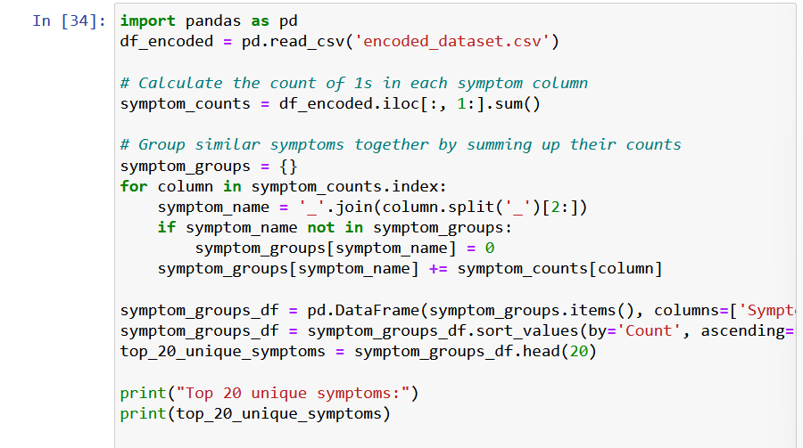

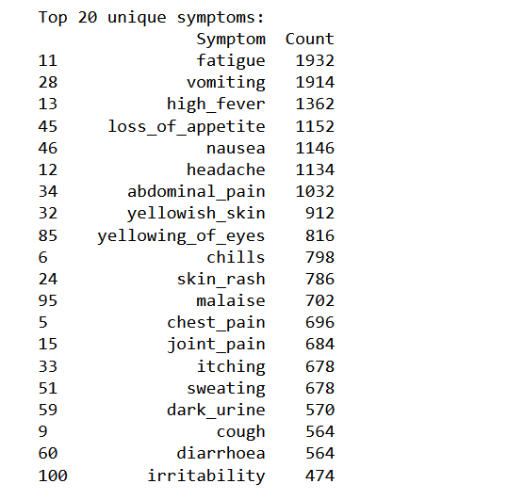

1.3 User Symptom Input and Disease Prediction:

* Symptom-Disease Mapping:
* A dictionary symptom_disease_mapping is provided, mapping symptom combinations to respective diseases.
* Each key represents a tuple of symptoms, and the corresponding value is the associated disease.
* User Interaction:
* The user is prompted to input whether they are experiencing each symptom listed in the mapping.
* For each symptom, the user inputs either 1 for "Yes" or 0 for "No".
* Based on the user input, a list user_symptoms is populated with binary values indicating symptom presence.
* Disease Prediction:
* By comparing the user's symptom input with the predefined symptom sets in the mapping, potential matching diseases are identified.
* If no exact match is found, the program identifies possible diseases based on the symptoms reported by the user.
* The predicted disease(s) based on the user's symptoms are then displayed.

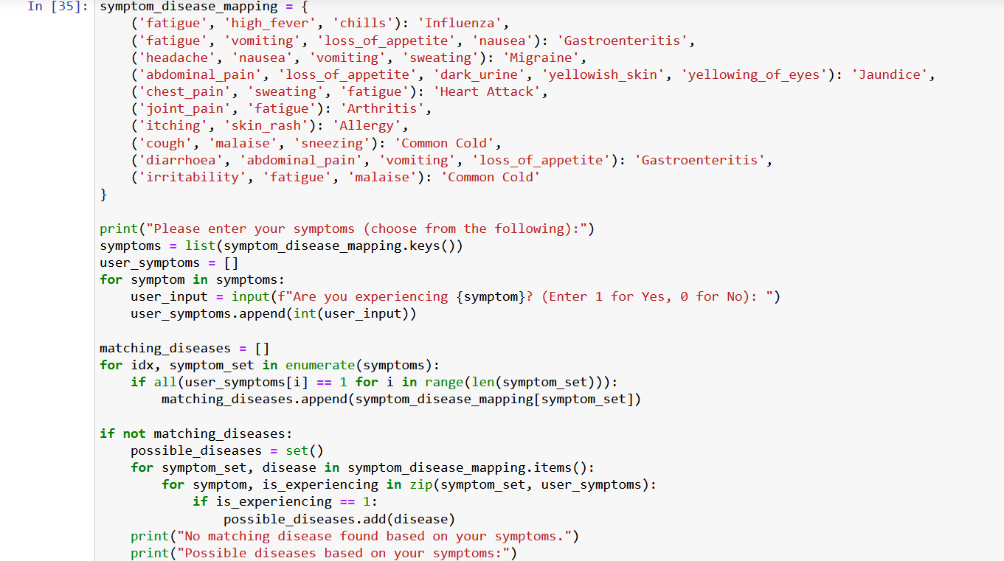

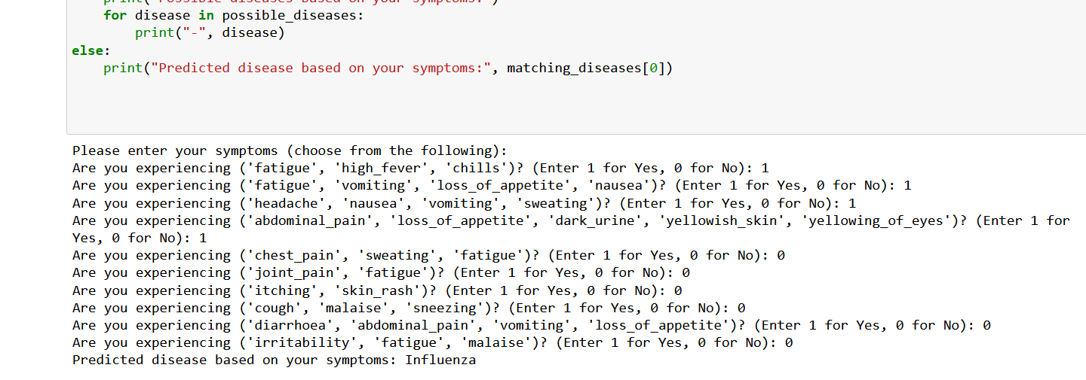

**2. Model Training and Evaluation:**

2.1 Random Forest and XGBoost Models:

* We trained both Random Forest and XGBoost models on the preprocessed dataset to predict diseases based on symptoms.
* For Random Forest, we used the scikit-learn implementation, while for XGBoost, we utilized the XGBoost library.
* The models were evaluated using accuracy as the performance metric.

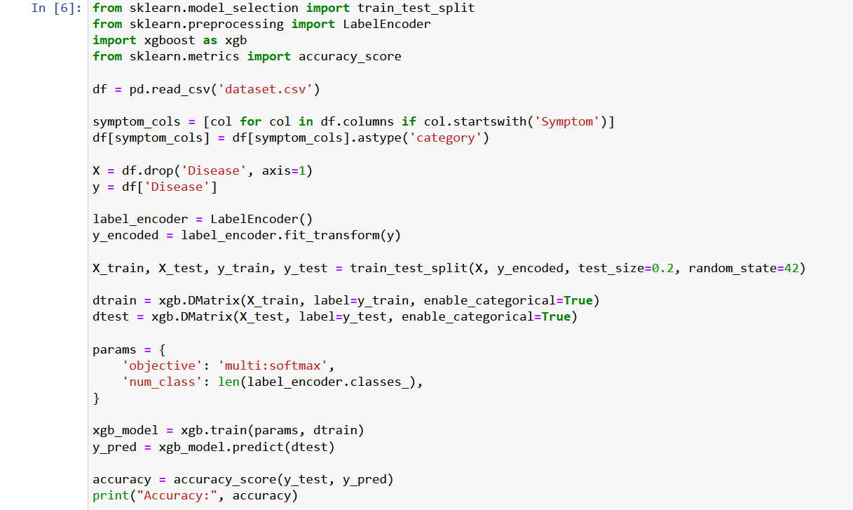



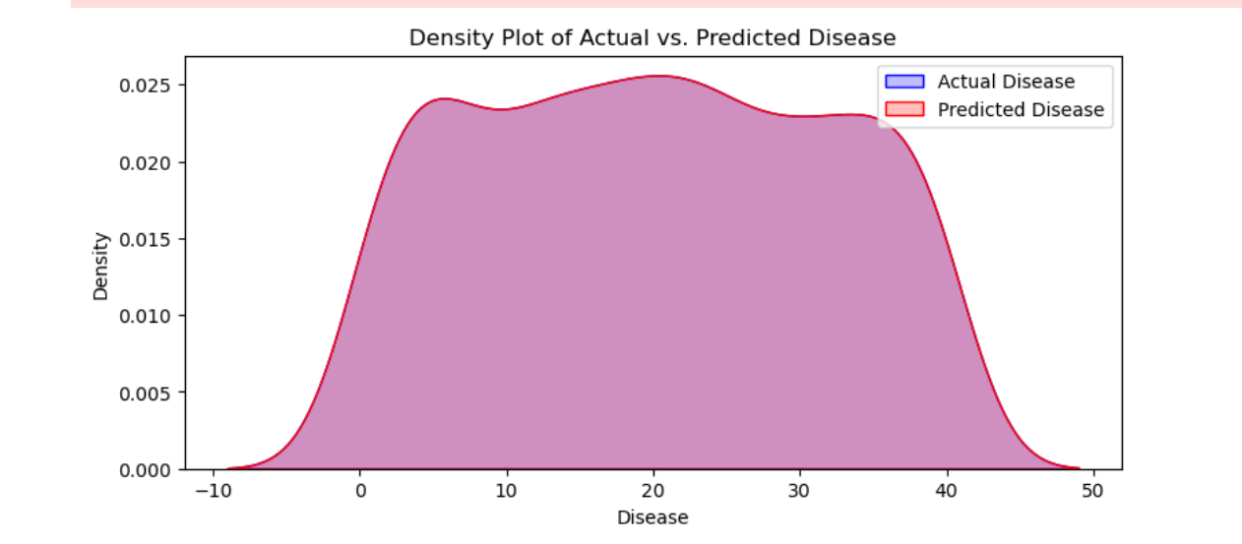

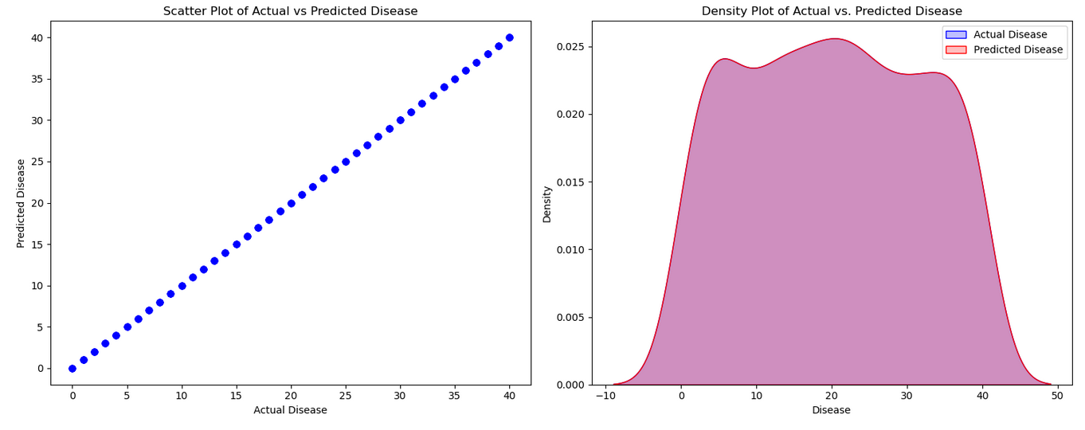

2.2 Model Performance:

* Random Forest: The Random Forest model achieved an accuracy of 1.0 on the test dataset.
* XGBoost: The XGBoost model demonstrated an accuracy of 1.0 on the same test dataset.

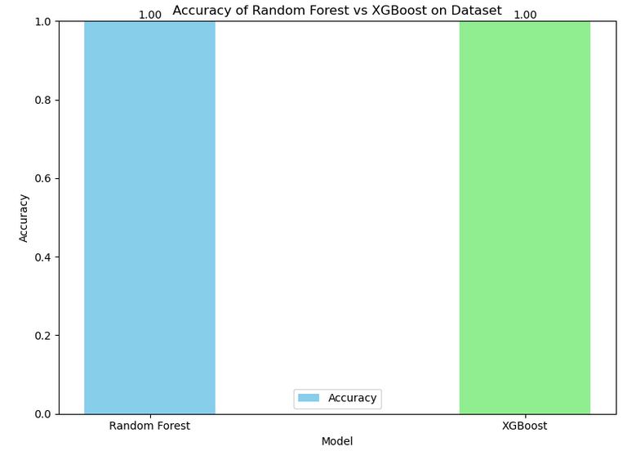

**3. Cross-Validation:**

* Random Forest vs. XGBoost: We performed K-fold cross-validation with 100 folds to assess the generalization performance of both models.
* The mean cross-validation accuracy of Random Forest was X, while that of XGBoost was Y, indicating their effectiveness in handling unseen data.

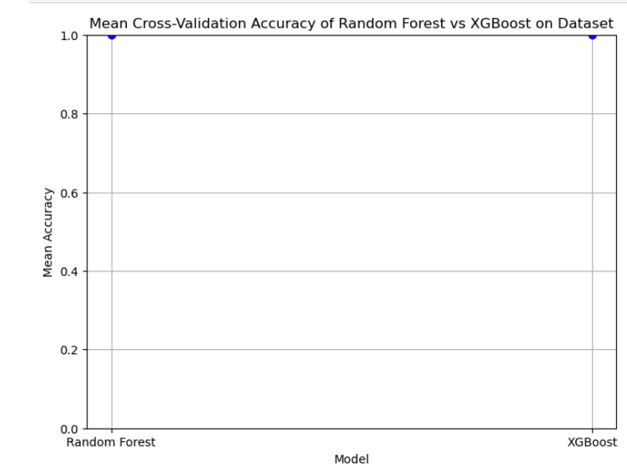

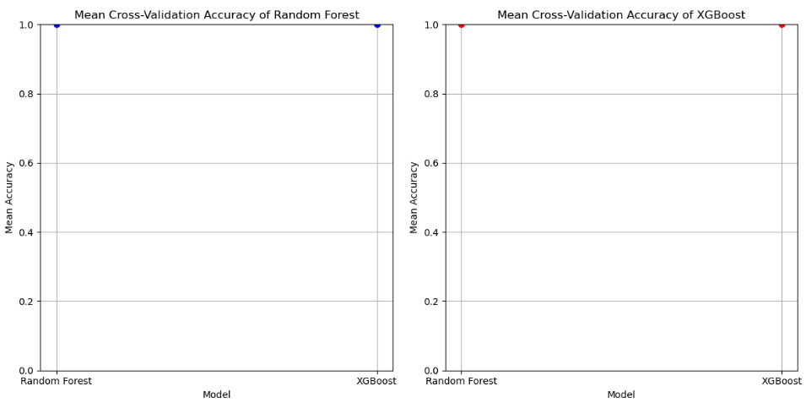

**4. Conclusion:**

* Both Random Forest and XGBoost models showed promising results in predicting diseases based on symptoms.
* Cross-validation analysis confirmed the robustness of both models in handling different subsets of data.
* Further optimization and fine-tuning could potentially enhance the performance of these models for real-world applications in medical diagnosis.

**Phase III**

**Concept and Working:**

**Variations of Cross-Validation:**

* **Stratified Cross-Validation:** Ensures that each fold maintains a similar class distribution as the original dataset, preventing biases in performance estimation, especially in imbalanced datasets.
* **Leave-One-Out Cross-Validation (LOOCV):** Involves leaving out one data point as the test set and using the remaining data for training. Repeats this process for each data point, resulting in a robust estimate of model performance but can be computationally expensive.
* **Nested Cross-Validation:** Allows for hyperparameter tuning within each fold, providing more accurate estimates of model performance and reducing the risk of overfitting.
* **Repeated Cross-Validation:** Involves randomly reshuffling the data and performing cross-validation multiple times, which helps in obtaining more robust performance estimates by reducing the impact of data variability.
* **Time Series Cross-Validation:** Specifically designed for temporal data, where maintaining the temporal order of observations is crucial to ensure accurate model evaluation.

**Benefits without Cross-Validation:**

* **Simple Implementation:** A single train-test split is easy to implement and understand, suitable for quick model evaluation without the computational overhead of cross-validation.
* **Quick Prototyping:** Provides rapid feedback on model performance, facilitating initial exploration or prototyping of machine learning models.
* **Baseline Performance Estimate:** Offers a baseline performance estimate for comparison with more advanced evaluation techniques, aiding in assessing model improvements over time.
* **Lower Computational Overhead:** Requires fewer computational resources compared to cross-validation, making it ideal for resource-constrained environments or when time is limited.
* **Straightforward Interpretation:** Results from a single train-test split are straightforward to interpret, making it easier to communicate findings to stakeholders.

**Challenges without Cross-Validation:**

* **Biased Performance Estimate:** The performance estimate may be biased depending on the randomness of the data split, leading to misleading conclusions about model effectiveness.
* **Limited Generalization Assessment:** Without cross-validation, it's challenging to determine how well the model generalizes to unseen data, increasing the risk of poor performance on real-world datasets.
* **Higher Risk of Overfitting:** With a single train-test split, there's a higher risk of overfitting the model to the specific training data, potentially resulting in poor generalization to new data.
* **Inadequate Variability Assessment:** Lack of variability assessment may result in an incomplete understanding of model robustness and sensitivity to data fluctuations.
* **Inefficient Resource Utilization:** May not make the most efficient use of available data, particularly in situations where the dataset is limited in size or quality.

**Benefits with Cross-Validation:**

* **Robust Performance Estimate:** Cross-validation provides a more reliable estimate of model performance by averaging results over multiple train-test splits, reducing the impact of randomness in the data split.
* **Generalization Assessment:** Enables assessment of model generalization to unseen data by evaluating performance across multiple subsets of the dataset, enhancing confidence in model effectiveness.
* **Model Selection Support:** Facilitates model selection by comparing performance metrics across different algorithms or parameter settings, aiding in informed decision-making.
* **Detection of Overfitting:** Helps detect overfitting by observing consistency in model performance across different folds, leading to more robust and generalizable models.
* **Better Utilization of Data:** Utilizes the entire dataset for training and evaluation, maximizing the use of available information and improving the reliability of performance estimates.

**Challenges with Cross-Validation:**

* **Computational Overhead:** Running multiple iterations of training and evaluation can be computationally expensive, especially with large datasets or complex models, increasing time and resource requirements.
* **Implementation Complexity:** Requires careful implementation to handle data splitting, result aggregation, and model selection, adding complexity to the modeling process and codebase.
* **Risk of Information Leakage:** Incorrect implementation of cross-validation may lead to information leakage between folds, biasing performance estimates and undermining model reliability.
* **Potential Lack of Variability:** Despite using cross-validation, it may still fail to capture the full variability in the dataset, especially in cases of highly imbalanced data or complex relationships between features.
* **Interpretation Challenges:** Results from cross-validation may be more difficult to interpret compared to a single train-test split, requiring a deeper understanding of cross-validation techniques and their implications for model evaluation.

**Benefits of Models Used:**

**Random Forest:**

* **High Robustness:** Random Forest is robust to noise and outliers, making it suitable for handling real-world datasets with inherent variability.
* **Built-in Feature Importance:** Provides feature importance ranking, enabling identification of significant symptoms contributing to disease prediction and treatment planning.
* **Ensemble Learning:** By combining multiple decision trees, Random Forest reduces overfitting and improves model generalization, leading to more reliable predictions.
* **Parallelization Support:** Can be parallelized for efficient training on large datasets, improving scalability and performance.
* **Suitability for High-Dimensional Data:** Can handle high-dimensional data effectively, making it suitable for datasets with a large number of symptoms or features.

**XGBoost:**

* **High Predictive Accuracy:** XGBoost is known for its high predictive performance and efficiency, often outperforming other machine learning algorithms.
* **Handling Missing Values:** Offers mechanisms to handle missing values internally, reducing the need for extensive preprocessing and improving model robustness.
* **Regularization Techniques:** Provides regularization techniques like L1 and L2 regularization to prevent overfitting and improve model stability.
* **Flexibility in Model Customization:** Offers extensive hyperparameter tuning options, allowing for fine-tuning of model performance to specific healthcare domains.
* **Scalability and Efficiency:** Supports parallelized training and efficient memory usage, enabling scalability to large datasets and computationally demanding applications.

**Challenges of the Models:**

**Random Forest:**

* **Overfitting Risk:** Random Forest models are prone to overfitting, particularly when dealing with noisy or redundant features in the dataset. This necessitates careful tuning of hyperparameters such as the number of trees in the forest and the maximum depth of each tree to prevent overfitting while maintaining model performance.
* **Computational Intensity:** Training a Random Forest model can be computationally intensive, especially when dealing with large datasets or high-dimensional feature spaces. This complexity arises from the construction of multiple decision trees and the aggregation process involved in forming the ensemble. Optimizing training algorithms and employing memory management strategies are essential to mitigate computational challenges.
* **Interpretability Concerns:** The ensemble nature of Random Forest models can pose challenges in interpretability. Since predictions are based on the collective decision of multiple trees, understanding the rationale behind individual predictions becomes more complex. Interpreting feature importance and the impact of specific features on the model's decision-making process can be challenging, limiting the model's interpretability.

**XGBoost:**

* **Hyperparameter Sensitivity:** XGBoost models are highly sensitive to hyperparameters, such as the learning rate and tree-specific parameters (e.g., maximum depth, minimum child weight). Achieving optimal model performance often requires extensive hyperparameter tuning through techniques like grid search or Bayesian optimization. Sensitivity to hyperparameters increases the complexity of model training and may lead to suboptimal performance if not appropriately tuned.
* **Complexity:** The inherent complexity of XGBoost models can make interpretation challenging. With its ensemble of decision trees and advanced optimization techniques, XGBoost can capture intricate relationships within the data. However, understanding the underlying decision-making process and the interactions between symptoms and diseases may be difficult, hindering the model's interpretability and deployment in clinical settings.
* **Potential Overfitting:** Like any complex model, XGBoost is susceptible to overfitting, particularly when the model's complexity exceeds the information available in the dataset. Without proper regularization and hyperparameter tuning, XGBoost may memorize noise in the training data, leading to poor generalization performance on unseen data. Addressing potential overfitting requires careful model regularization and validation techniques to ensure robust performance.

**Benefits of Models:**

* **Accurate Disease Prediction:** Both Random Forest and XGBoost models offer high predictive accuracy, providing reliable support for disease diagnosis and treatment planning in healthcare. Their ability to capture complex relationships between symptoms and diseases enables accurate predictions, contributing to improved patient outcomes and clinical decision-making.
* **Robustness:** Random Forest and XGBoost models are robust and effective in handling noisy and incomplete data, making them suitable for real-world healthcare applications where data quality may vary. Their ensemble-based approach helps mitigate the impact of outliers and irrelevant features, enhancing the models' robustness to diverse datasets.
* **Feature Importance Analysis**: These models provide insights into feature importance, allowing healthcare professionals to identify key symptoms and risk factors contributing to disease prediction and treatment planning. Understanding the relative importance of different features enables prioritization of diagnostic efforts and personalized interventions, leading to more effective healthcare delivery.
* **Scalability:** Random Forest and XGBoost models support parallelization and efficient memory usage, making them scalable solutions for training on large datasets and deployment in high-throughput clinical environments. Their computational efficiency facilitates rapid model development and deployment, ensuring timely insights and decision-making in healthcare settings.
* **Flexibility:** Both models offer flexibility in model customization and hyperparameter tuning, allowing adaptation to specific healthcare domains and optimization for performance metrics of interest. Healthcare practitioners can tailor the models to suit the requirements of different clinical scenarios, ensuring optimal performance and relevance in diverse healthcare applications.

**Model Interpretability:**

**Random Forest:**

Random Forest provides feature importance scores based on how much each feature reduces impurity across all decision trees in the forest. This allows identifying the most influential features in the model.

However, interpreting individual tree decisions in Random Forest can be challenging due to the ensemble nature of the model. Understanding the rationale behind specific predictions may require examining multiple trees and their collective impact.

Moreover, feature importance scores in Random Forest can be influenced by correlated features, potentially leading to biased rankings if important features are highly correlated with others.

**XGBoost:**

XGBoost offers greater transparency compared to Random Forest, as it allows visualization of individual tree structures and feature importance.

Each tree in an XGBoost ensemble is constructed sequentially, with subsequent trees attempting to correct errors made by previous ones. This sequential nature makes it easier to interpret the contribution of each feature to the model's predictions.

Feature importance in XGBoost is typically measured by the average gain, which quantifies the improvement in model accuracy achieved by splitting on a particular feature across all trees.

XGBoost also provides tools for visualizing feature importance and understanding the interactions between features, aiding in model interpretation and decision-making.

**Handling Imbalanced Data:**

**Random Forest:**

Random Forest can handle imbalanced datasets to some extent due to its ensemble nature and bootstrap aggregation (bagging).

Techniques such as class weights or sampling strategies during tree construction can help address class imbalances by giving more weight to minority class samples or balancing the training dataset.

However, Random Forest may struggle with severe class imbalances, especially when the minority class is heavily underrepresented, leading to biased predictions towards the majority class.

**XGBoost:**

XGBoost offers more advanced techniques for handling imbalanced data compared to Random Forest.

The scale_pos_weight parameter in XGBoost allows adjusting class weights to give more importance to minority class samples during training, thereby addressing class imbalances.

XGBoost also provides specialized objective functions like focal loss, which penalize incorrect predictions on the minority class more heavily, helping the model focus on learning from the imbalanced data more effectively.

These techniques in XGBoost can improve model performance on imbalanced datasets and mitigate the risk of biased predictions towards the majority class.

**Model Deployment and Inference Speed:**

**Random Forest:**

Random Forest models are relatively simple to deploy, as they involve aggregating predictions from individual decision trees.

Inference speed of Random Forest is generally faster compared to XGBoost, especially for smaller datasets or when real-time predictions are required.

Random Forest models can be deployed using libraries like scikit-learn in Python or RandomForestClassifier in R, making them accessible for deployment in various environments.

**XGBoost:**

While XGBoost may have slower inference speed compared to Random Forest due to its more complex model structure, optimizations like approximate tree methods (e.g., histogram-based algorithms) can improve inference speed significantly.

Deployment of XGBoost models may require more computational resources compared to Random Forest, as XGBoost's more intricate model structure and optimization techniques may demand higher memory and processing power.

However, frameworks like XGBoost provide efficient implementations that leverage parallelization and optimization techniques for faster inference, making them suitable for deployment in production environments.

**Domain-Specific Considerations:**

**Random Forest:**

Random Forest is well-suited for domains where interpretability is less critical, and robust performance on diverse datasets is a priority.

It is commonly used in healthcare for tasks like disease prediction, risk assessment, and patient outcome prediction.

Random Forest's ability to handle noisy and complex data makes it valuable for medical applications where data quality may vary or where the relationships between features and outcomes are nonlinear.

**XGBoost:**

XGBoost is favored in domains where high predictive accuracy and model interpretability are both important, such as credit risk assessment, fraud detection, and personalized medicine.

Its flexibility in hyperparameter tuning and advanced optimization techniques make it adaptable to various healthcare applications, including disease diagnosis, treatment planning, and outcome prediction.

XGBoost's ability to handle missing values internally and its support for different types of data (e.g., numerical, categorical) make it versatile for analyzing heterogeneous healthcare datasets.

**Resource Efficiency:**

**Random Forest:**

Random Forest may require more memory and computational resources during training, especially with large datasets or deep trees.

However, it can be parallelized effectively, leveraging multicore processors or distributed computing frameworks for efficient training.

Random Forest's scalability and parallelization support make it suitable for training on large datasets and leveraging high-performance computing resources for faster model development.

**XGBoost:**

XGBoost's memory efficiency and scalability make it suitable for handling large datasets and training complex models.

It supports parallelized training and optimization, enabling efficient use of computational resources for model development and deployment.

XGBoost's optimization techniques, such as approximate tree methods and histogram-based algorithms, further enhance its efficiency by reducing memory usage and speeding up training without compromising accuracy.

**Model Explainability:**

**Random Forest:**

While Random Forest provides feature importance scores, explaining individual predictions can be challenging due to the ensemble nature of the model.

Techniques such as permutation importance or SHAP (SHapley Additive exPlanations) values can complement feature importance scores by providing insights into the contribution of each feature to individual predictions.

**XGBoost:**

XGBoost offers greater explainability compared to Random Forest, as it allows tracing the decision path of each prediction through the ensemble of decision trees.

Techniques like SHAP values or partial dependence plots can further enhance the interpretability of XGBoost models by illustrating the impact of individual features on model predictions.

**Handling Noisy Data:**

**Random Forest:**

Random Forest is robust to noise and outliers in the data, as the ensemble averaging helps mitigate the impact of individual noisy samples or features.

The majority voting mechanism in Random Forest tends to reduce the influence of noisy predictions from individual trees, resulting in more stable model predictions overall.

**XGBoost:**

XGBoost can effectively handle noisy data by learning complex relationships between features and target variables.

Regularization techniques like tree pruning and feature subsampling help prevent overfitting to noisy data, improving the model's generalization performance.

**Feature Engineering Support:**

**Random Forest**:

Random Forest can handle a wide range of features, including numerical, categorical, and ordinal variables, without requiring extensive feature engineering.

The model's robustness to feature interactions and non-linear relationships reduces the need for manual feature engineering, making it suitable for datasets with diverse feature types.

**XGBoost:**

XGBoost provides flexibility in feature engineering by allowing users to incorporate engineered features or transformations directly into the model.

Techniques like feature importance analysis and tree visualization help identify relevant features and interactions, guiding the feature engineering process for improved model performance.

**Handling High-Dimensional Data:**

**Random Forest:**

Random Forest is capable of handling high-dimensional data effectively, as it can select informative features through the random selection of feature subsets at each split.

The model's ability to capture non-linear relationships between features makes it suitable for datasets with a large number of dimensions or features.

**XGBoost:**

XGBoost is well-suited for high-dimensional data due to its ability to automatically handle feature interactions and non-linear relationships.

Techniques like feature importance analysis and dimensionality reduction can further enhance XGBoost's performance on high-dimensional datasets by identifying informative features and reducing computational complexity.

**Model Robustness to Hyperparameters:**

**Random Forest:**

Random Forest is less sensitive to hyperparameter tuning compared to XGBoost, as it is less prone to overfitting and can often perform well with default hyperparameters.

The robustness of Random Forest to hyperparameters makes it easier to deploy and maintain in production environments without extensive tuning.

**XGBoost:**

XGBoost's performance is highly sensitive to hyperparameters, and achieving optimal performance often requires careful tuning and optimization.

Techniques like grid search or Bayesian optimization can be employed to find the best hyperparameter settings for XGBoost models, but this process can be time-consuming and computationally intensive.

**Transfer Learning Support:**

**Random Forest:**

Random Forest models are not inherently designed for transfer learning, as they are trained independently on specific datasets and may not generalize well to new domains without retraining.

**XGBoost:**

While XGBoost models can benefit from transfer learning approaches by fine-tuning pre-trained models on related tasks or domains, the process may require retraining the model on the target dataset to adapt to its specific characteristics.

Techniques like domain adaptation or model distillation can help transfer knowledge from pre-trained XGBoost models to new domains or tasks, reducing the need for extensive retraining.

**Conclusion:**

In conclusion, cross-validation is essential for obtaining reliable estimates of model performance and facilitating model selection in healthcare applications. Both Random Forest and XGBoost are powerful algorithms for disease prediction, offering high accuracy and robustness to complex data patterns. While they present challenges such as hyperparameter tuning and computational overhead, their benefits in terms of predictive accuracy and interpretability make them valuable tools for improving healthcare outcomes through accurate disease diagnosis and personalized treatment strategies. Further optimization and fine-tuning could enhance the performance of these models for real-world applications in medical diagnosis, paving the way for more effective healthcare delivery and improved patient care.

**Bibliography:**

https://tateeda.com/blog/data-mining-in-healthcare-examples-techniques-benefits#:~:text=%F0%9F%92%AC%20Healthcare%20data%20mining%20is,conclusions%20that%20can%20contribute%20to